

STEM Grid P6-7
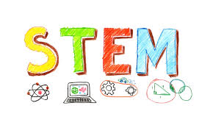
During our STEM Week there are 10 activities that you can use at home to help children develop your science, technology, engineering and maths skills. These activities are easy to resource, however, please adapt to any resources you have at home! These activities provide children with the stimulus to talk about the world around them. Don’t forget to please share your work with us, if possible. We would love to see what you are up to!

Technology - Scratch  Coding is just a set of instructions – if you write the instructions carefully and precisely then what can go wrong? Try creating a game on Scratch. No idea where to start – check out the ideas page!  https://scratch.mit.edu/ideas | Science - Rainbow Chromatography  Did you know that ink in a black pen is not black! Try to separate colours one at a time at first to see what happens and then use more than one colour to make a rainbow effect.  https://www.stem.org.uk/resources/elibrary/resource/33257/rainbow-colours  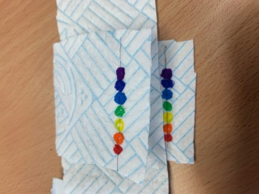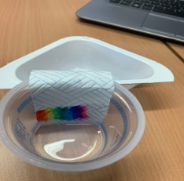 | Engineering - Paper planes  We all like making paper planes but how do we make the ultimate paper plane – watch the video linked below and have a go yourself!  https://www.stem.org.uk/home-learning  https://www.youtube.com/watch?v=QkTrrXMJWII  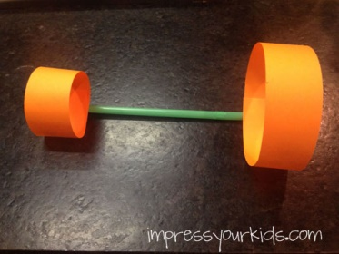
Engineering – build a catapult  Investigate cause and effect and the conservation of energy and momentum by building a catapult using materials you find at home. Watch the video link for inspiration!  https://www.youtube.com/watch?v=gOFWm4xbSro | Science/Engineering – make a rocket!  Who doesn’t love rockets? There are many different ways to create an explosive effect – this is just one of them for you to try!  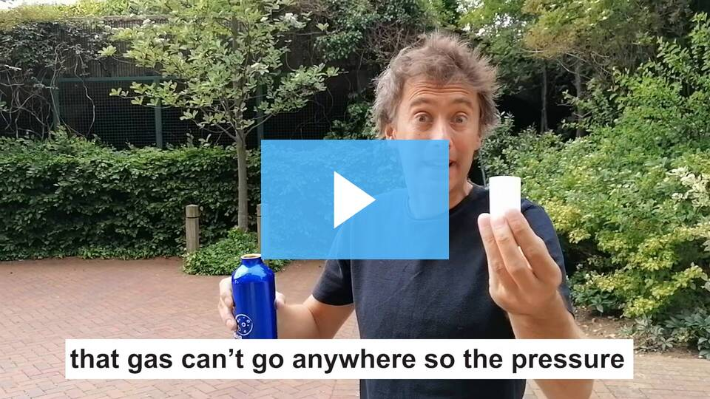  How to make a rocket at home: Everyday engineering with Dallas Campbell | Science – skeletal system  Investigate the skeletal system by creating your own moving model of a hand using everyday objects!  https://www.livinglifeandlearning.com/muscular-system-hand-craft-for-kids.html  Once you’ve done this, why not tape/tie your thumbs to the side of your hand and challenge yourself to do basic tasks such as opening the door or using the phone. Be careful not to use tape that's too tight or too strong! It doesn't sound too difficult since you still have all your fingers but it's surprising how much we use our thumbs! If you manage the basic tasks, try something more challenging like writing or tying shoelaces! Have fun! (The point of this task is to develop your problem solving and creativity by the way!)
Technology – Hovercraft  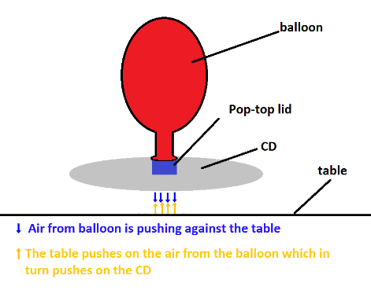  https://sciencebob.com/build-a-tabletop-hovercraft-2/  https://www.youtube.com/watch?v=dy-61HV2FRw | Science – digestive system  Learn about digestion while making a working model of the digestive system – from beginning to end! Enjoy!  https://www.bbc.co.uk/bitesize/topics/zf339j6/articles/zrm48mn   | Design and Technology – Squashed tomato  Imagine you wanted to send a tomato you had grown in your garden through the post – how could you protect it so it didn’t arrive all squashed?  Your challenge is to use materials around the house to create packaging to protect your tomato so it will survive the perilous journey through the mail! Once it’s all packaged up, design a test to check its durability. Have fun!  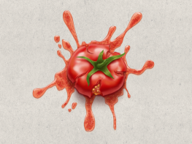
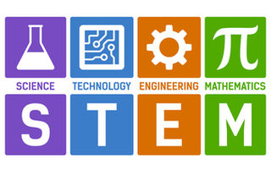 | Maths – Code Cracking  Who doesn’t like a spy movie or trying to crack a code? Well, now it’s your turn – there’s a comprehensive guide to cracking codes on the link below as well as different levels of code for you to crack – good luck!  https://www.transum.org/software/Fun_Maths/Code/ | 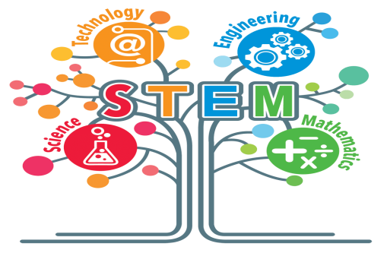  Share your learning on Teams!

