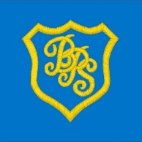

STEM Grid P1-3
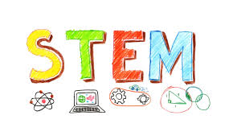
During our STEM Week there are 10 activities that you can use at home to help children develop your science, technology, engineering and maths skills. These activities are easy to resource, however, please adapt to any resources you have at home! These activities provide children with the stimulus to talk about the world around them. Don’t forget to please share your work with us, if possible. We would love to see what you are up to!

Interesting insects  How many different in-sects can you name? Can you find any insects near where you live?  https://www.stem.org.uk/cxes6z  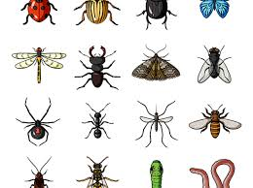 | Spotting shapes  When you are out on a walk see what shapes you can spot. Can you find 3 things that are the shape of a square, 3 circles and 3 triangles?  https://www.stem.org.uk/rxwhq  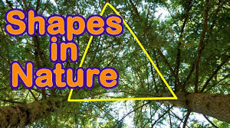 | Stop apples from browning  Slice up an apple, and let each slice soak in a different liquid, e.g. water, honey water, milk, lemon juice. Then take them out, lay them on a tray, and check the brownness after three minutes, six minutes, and so on.  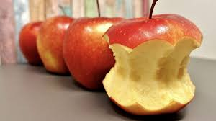
Brilliant bodies  Try testing your body by seeing how long you can balance for or make a reaction tester to see how good your reactions are. Download a reaction tester here.  https://bit.ly/3cp0FED  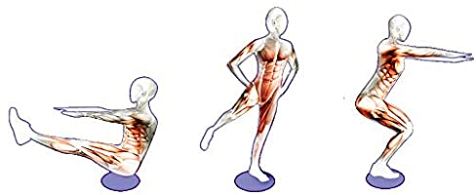 | Spaghetti shapes  Can you build a cube using 4 marshmallows and 12 half lengths of un-cooked spaghetti? How wobbly is it? Can you make it stronger using more half lengths of spaghetti? Try making a pyramid with marshmallows and spaghetti. Which is the stronger of your two shapes?  https://www.stem.org.uk/rxfjyo  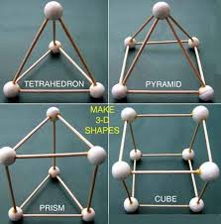 | Secret messages  Use a cotton bud dipped in lemon juice to write a message on paper. Let the juice dry and then heat the message with a hair dryer. Your secret message should appear.  https://www.youtube.com/watch?v=_OiAxu6jdxg  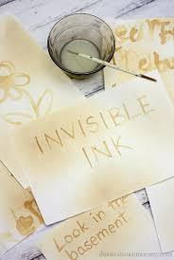
Pepper and soap trick  Pop some water in a bowl. Sprinkle some pepper flakes onto the water. Put a bit of liquid soap, or washing up liquid on your finger and dip that finger into the bowl. Ob-serve what happens to the pepper flakes. Why are people likening this to washing hands? | Good vibrations  Cut a piece of thread, make sure it is a bit longer than your arm.  Tie the middle of it around the handle of a fork.  Wind each end of the thread around one finger on each of your hands, so you are holding the thread, with the fork dangling down.  Place your fingers just near your ears, but not inside them! Knock the fork gently against a table.  What can you hear?  https://bbc.in/2XrXHuG | Beulah Henry 1912 – 1970  Beulah was a famous American inventor who invented over 100 new products. She made sever-al umbrella inventions from clip on covers to special umbrella bags.  If you were going to design an umbrella what would it look like and what materials would you use?  Try making a model umbrella using junk box materials you might find at home.  https://bit.ly/2XYFu72
 | Creating crystals  Fill an old jar with water and pour salt, stirring to dissolve it. Keep adding salt until no more can dissolve. Tie a paperclip onto a length of cotton and hang it from a straw, or piece of wood placed across the top of the jar. Leave the jar some-where safe and obverse what happens over the next few days and weeks.  https://www.stem.org.uk/rxyxp | 

